COMP229 – Web Application Development

Mid-Term Test
Week 7
Value 15%
Mid-Term Test Maximum Mark: 100
Overview: Using your knowledge of NodeJS and ExpressJS, React and the Web App Template provided, complete the Portfolio web app. Your web app is a complete full stack web app without Authentication. Your task is to complete the code that is missing from the routes, controller and Test the API’s.

Project Setup:
- Rename the Web App Template provided to COMP229-F2024-MidTerm-[YourStudentID]. (e.g. COMP229-F2024-MidTerm-300929668).
- You will need to create a new Mongo Database named Skeleton or use your existing Skeleton database. You will need to change or add the URI variable in the db config file (config/config.js) to connect to your database.
- You will need to add some example project data in the database.

Instructions:
- The projects Routing File (routes/project.routes.js) already has a route working to find all the projects in the projects collection and render your project page.
Your task for this section is to complete the logic for each of the routes to render the project page based on the HTTP request to the route and the corresponding controller function as shown below:
此部分的任务是完成每个路由的逻辑，以根据对路由的 HTTP 请求和相应的控制器函数呈现项目页面，如下所示：
projects

Methods | Urls | Actions
GET | api/projects | get all projects
GET | api/projects/:id | get projects by id
POST | api/projects | add new project
PUT | api/projects/:id | update project by id
DELETE | api/projects/:id | remove project by id
DELETE | api/projects | remove all projects

- Add the corresponding controller function in the controllers/project.controller.js
在controllers/project.controller.js中添加相应的控制器函数
- cd client and run the command yarn dev or npm run dev ensure your app. Is connected to the database by checking the console for the message as shown below:

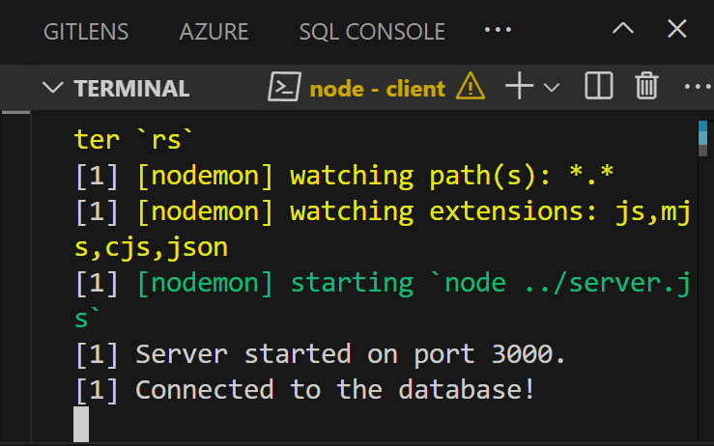

- a) Test the REST APIs using Postman, Thunder client or any tool you are familiar with. e.t.c.
b) Provide the screen snapshot of the test.
5. Check your MongoDB database to view the collection created and document inserted. Provide the snapshot to your MongoDB showing the document inserted.

SUBMITTING YOUR WORK
Your submission should include:
- A zip archive of the portfolio app.
  - Ensure to Name the portfolio app. COMP229-F2024-Midterm-[YourStudentID] e.g. COMP229-F2024-Midterm-300818557.zip
  - Please do not create a RAR archive of the portfolio app.

- The snapshot to the API Testing in a word or pdf file.
- The snapshot to your MongoDB showing the inserted documents.
This exam is weighted 15% of your total mark for this course.

